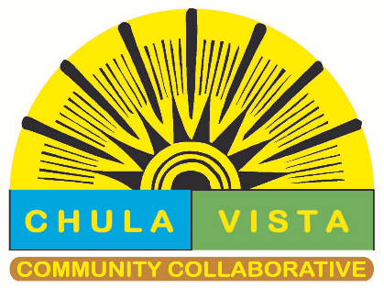
CHULA VISTA COMMUNITY COLLABORATIVE
PARTNERS MEETING MINUTES
MARCH 12, 2024

Start of meeting: 9:02am
Angela Tomlison, director of Chula Vista Community Collaborative provided an update of events from CVCC.

Southern Caregiver Resource Center
Presented: Caring for Those Who Care for Others
Southern Caregiver Resource Center (SCRC) offers services to family caregivers of adults with chronic and disabling conditions or diseases. With a team of highly qualified, professional staff, SCRC supports families through a full range of programs and services.

To be eligible for services, a client must be caring for an adult with a cognitive impairing condition that occurred after the age of 18 (for example: dementia, Alzheimer’s disease, stroke, traumatic brain injury, Parkinson’s disease), or someone age 60 years and older in need of assistance with daily living activities. Services are for residents of San Diego and Imperial counties.
​
All services come at no cost to the family caregiver, except for the Together Care Respite Program*. Both home and office visits are available by appointment

San Ysidro Health

Presented: Youth opioid response (and other substance use disorder services)
San Ysidro Health offers services to treat substance use disorders at several clinics throughout their network.
Patients that are ages 12 years and older and suffering from conditions such as alcohol use disorder, amphetamine-type use disorder, opioid use disorder, and sedative hypnotic anxiolytic use disorder are eligible to receive care at these locations.
Services include:
- Medical and mental health exam by an Addiction Medicine (SUD) Provider
- Medication Assisted Treatment (MAT) for opioid use disorder and alcohol use disorder.
- Ambulatory withdrawal management
- Substance use disorder (SUD) individual and group counseling with Certified SUD Counselor
- Assistance with placement in detox, residential, outpatient facility, or sober living facility
- Education on Harm Reduction and providing access to Naloxone (Narcan) for the reversal of opioid overdose.

‍San Ysidro Health’s Substance Use Disorder Clinics can also assist with:
- Withdrawal symptoms
- Infectious diseases such as tuberculosis, sexually transmitted illnesses, HIV, and hepatitis C.
- Insomnia, anxiety, depression, and other co-occurring mental health diagnosis related to substance use.
- Contraception and family planning services or linkage to care where appropriate.

24-Hour Home Care
Presented: Personal Care, Homemaker & Respite Service
Provide support to manage healthy conditions at home instead of a higher-cost facility -based setting.
- Personal Care
- Meal preparation
- Medication Reminders
- Supervision /Socialization
- Light housekeeping

Roundtable
- Mental Health First AID, Trainings
- BrightLife Kids 0-12 Free app for emotional and Behavioral health coaching
- Soluna 12-25 yr. Free app for emotional and Behavioral health coaching
- Jr’s. Trauma Care Initiative provides mental health counseling.
- Job corps, Free career Training and education options for 16–24-year-old
- ILA Program, the Independent Living Association (ILA) is a collaborative community-wide effort focused on supporting independent living operators, tenants and the community by promoting high quality independent living.

End of meeting: 10:55am

