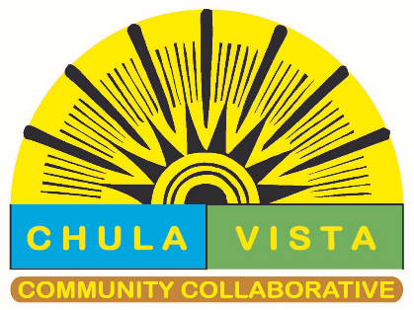
CHULA VISTA COMMUNITY COLLABORATIVE
PARTNERS MEETING MINUTES
February 13, 2024

Start of meeting: 9:02am
Angela Tomlison, director of Chula Vista Community Collaborative provided an update of events from CVCC.

HHSA
Presented Love Your Heart Event on 2/14/2024. Free blood pressure screening.
Will have meetings and fairs that benefit behavioral health. Is looking for organizations wanting to host tables for resource fair.

SAN DIEGO REGIONAL CENTER;
Private non-profit serving as state contractors. 21 agencies; in the State of California only.
Early intervention special focus on Migrant and undocumented babies. Referrals can be done by parents, social services, providers or anyone in the medical field. The intake process timeline is approximately 45 days. Can serve children after age 3 if developmental delay is continuing.
- SDRC Services: Service coordinator, development of IPP, Behavioral Consultation, Respite services

LOGAN HEIGHTS COMMUNITY DEVELOPMENT CORPORATION
Non-profit provides California Mortgage relief.
California Mortgage Relief Program | (camortgagerelief.org)
- Eligibility-Covid hardship, missed payments
- Financial- Below Area Medium income
- Can apply for mortgage or property tax relief
Preschool, free tax preparation (call 211 for appointment)

REAL CHOICES CHULA VISTA
- Provides pregnancy and parent support.
- Mobile ultrasound clinics can provide pregnancy verification for those who need it for WIC or Medi-Cal.
- Also provides parenting classes and court ordered or not.
- Post abortion support group- low cost and scholarship available
Services are free unless otherwise noted.

SCRIPPS
Well Being Center
- Breast Cancer Awareness: support group in Spanish. You do not have to be a Scripp member.
- Breastfeeding support Monday at 1pm.

GRID ALTERNATIVES
Non-profit; transition to Clean Energy
- Provides Solar Installation panels
- EV and EV charging stations
- Clean cars 4 all serving: some zip code assist with purchase of EV or Hybrid.

Roundtable
- Oral Health Month will have 2 events
- Alzheimer’s Association will have an event at Handlery April 3 from 6-8pm
- Free haircuts for kids Feb 17 from 11-3pm –Highland Ave Supply Company
- Wishwell counseling for kids and also provides resources.
- CSA of San Diego looking for paid participants in civil rights investigations.
- Amigaspuntocom provides workshops and counseling for our Latina community.
- Jewish Family Services will provide free citizenship courses.

End Meeting: 10:55am

